DevOps Lab (TP 4) – Individual Report
Oct 2, 2026 · @Luca
Luca Perkins – ESILV, 4th year – Student B, ticket DEVOPS-2

1. Context and team
This report documents my individual contribution to the ESILV Software Engineering & Development DevOps lab (TP 4): I planned the work in Jira, implemented the /info endpoint on a feature branch, got it through a pull request and a CI pipeline, and verified it with automated tests and a coverage report.
The lab covers one full DevOps loop: Plan (Jira), Code (GitHub, branches and pull requests), Build (GitHub Actions) and Test (Vitest and Supertest). The project is a small Node.js / Express application that automatically mounts every route file found in src/routes/auto/.
We worked as a team of four. Each student took one Jira story and one file:
Jira ticket | Student | Deliverable
DEVOPS-1 | Teammate | Teammate story (done)
DEVOPS-2 | Student B (me) | src/routes/auto/info.route.js, the /info endpoint
DEVOPS-3 | Teammate | Teammate story (done)
DEVOPS-4 | Teammate | Team-level item (in progress)
My assignment was DEVOPS-2: implement the /info endpoint so that it returns the application name, version, Node.js version and uptime.

2. Step 1 – Plan in Jira
I set up a team-managed Scrum space named DevOps Lab Node.js Project with the key DEVOPS. The workflow has four states: To do (À faire), In progress (En cours), Review and Done (Terminé). The Jira interface is in French, so ticket states appear under their French names in the screenshots.
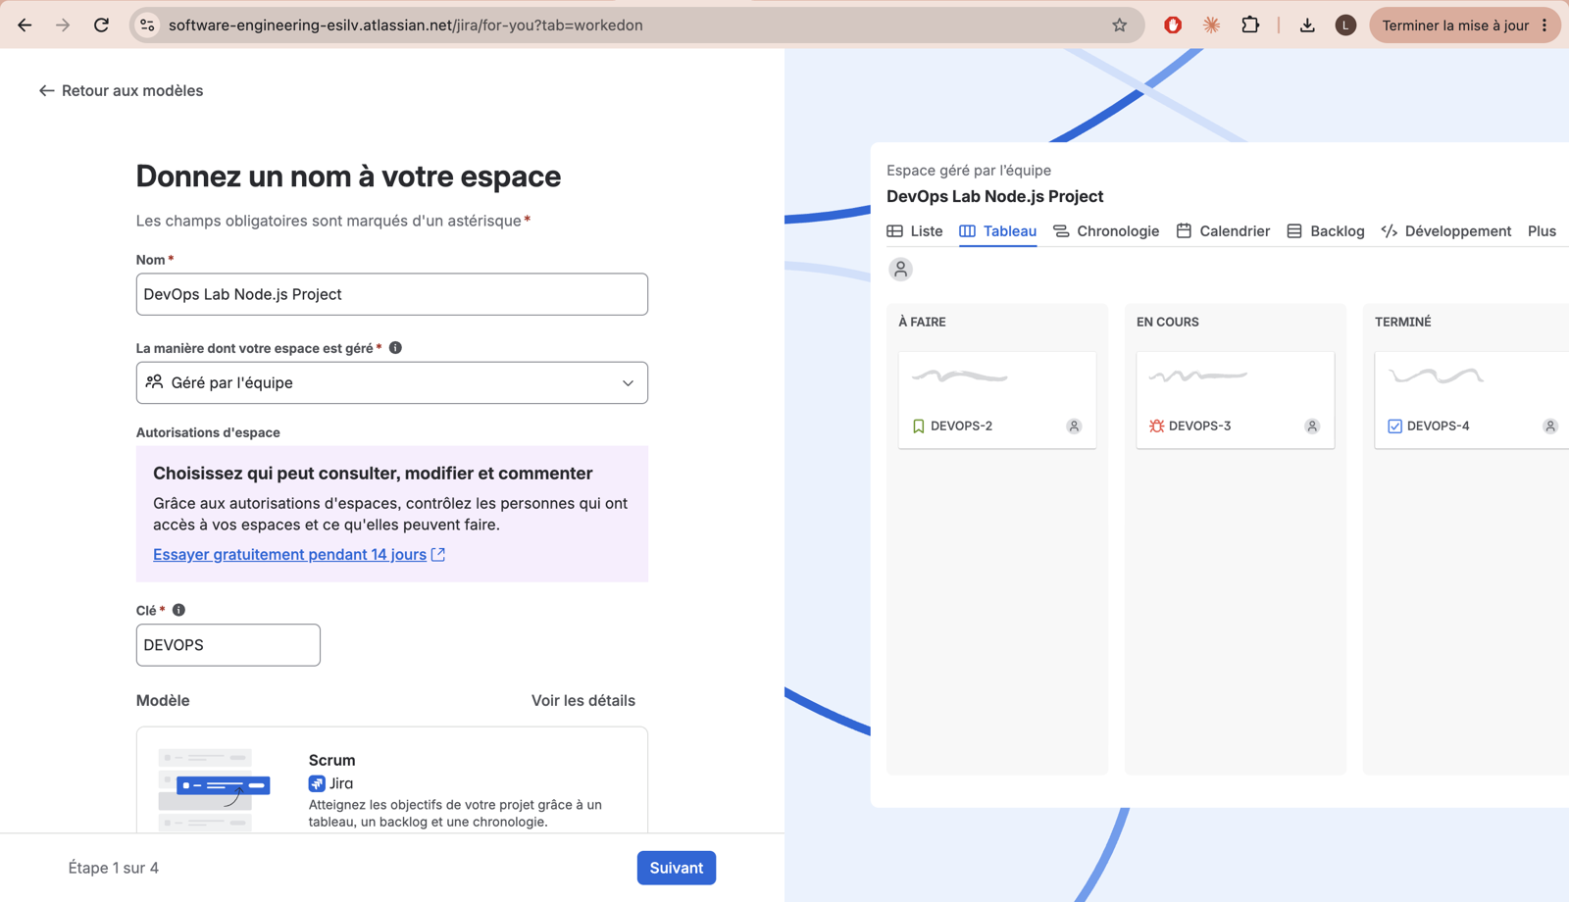
Figure 1 – Creating the Scrum space (name, team-managed, key DEVOPS).
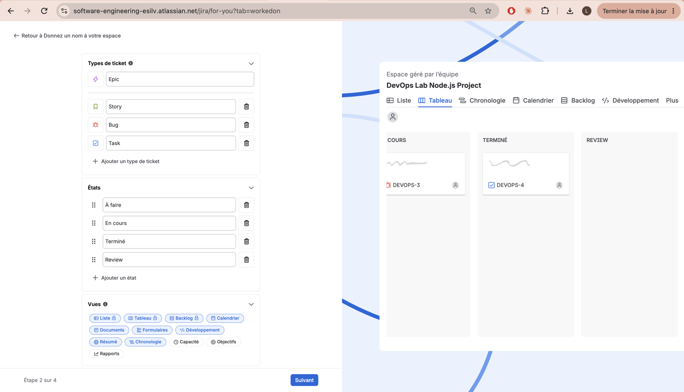
Figure 2 – Issue types (Epic, Story, Bug, Task) and workflow states, where I added a Review state for the pull-request step.
I then created one story per endpoint or utility in the sprint DEVOPS Sprint 1, so that each student owns a ticket:
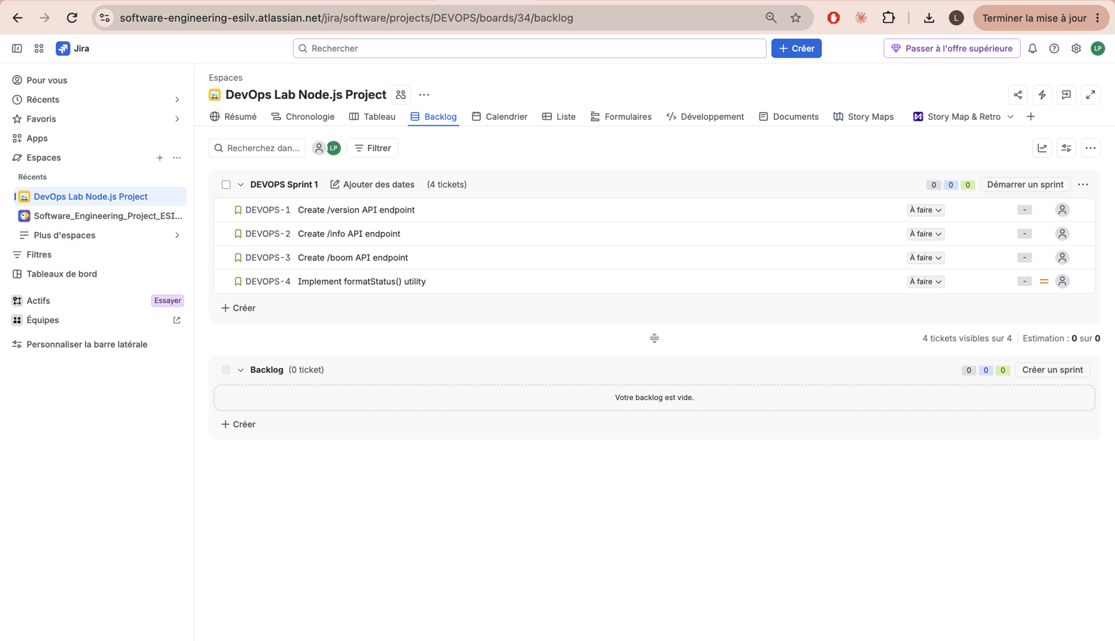
Figure 3 – Sprint backlog: DEVOPS-1 /version, DEVOPS-2 /info (mine), DEVOPS-3 /boom, DEVOPS-4 formatStatus().
Each story follows the same format: a user story sentence and acceptance criteria (expected response, status code, the integration test that must pass, and the rule that the commit and branch name must include the ticket key).
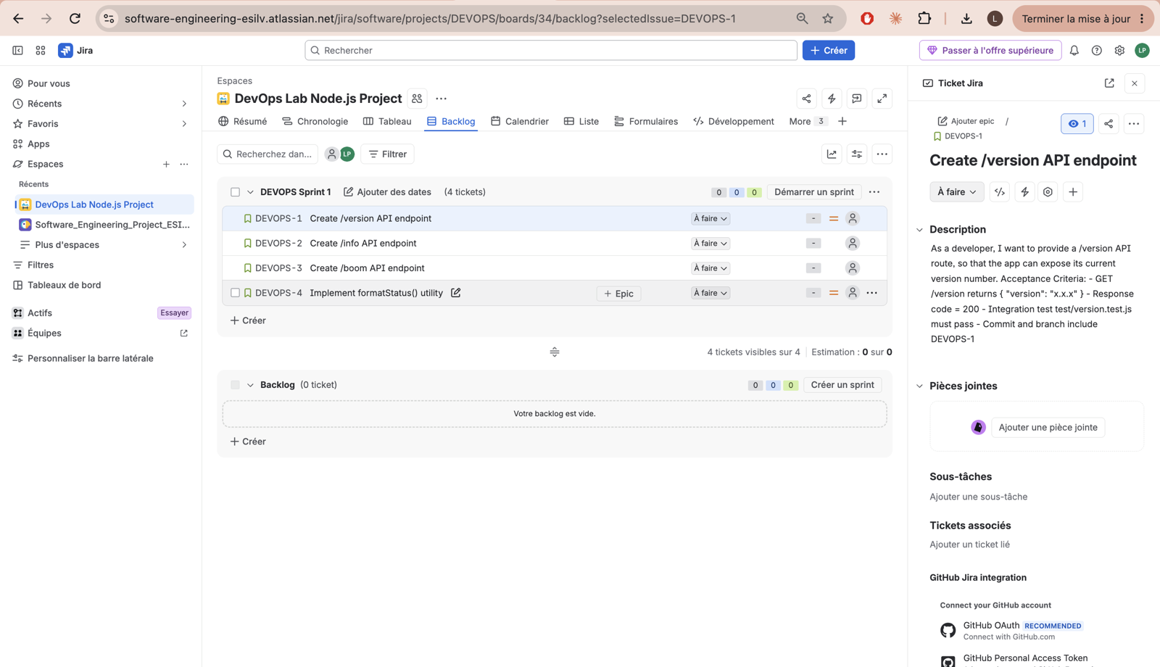
Figure 4 – Example of a story with acceptance criteria (DEVOPS-1). The right panel also shows the GitHub for Jira integration.
Finally, I grouped the stories under an epic, API Core Development, and checked the result on the board.
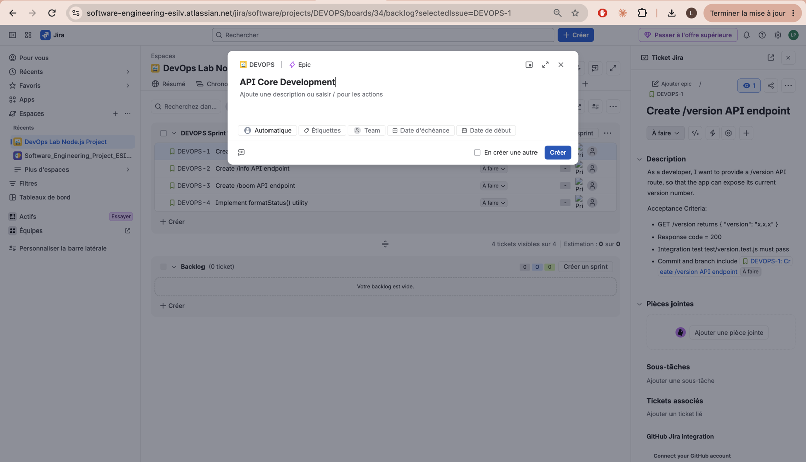
Figure 5 – Creating an epic from the top "Create" button (type Epic).
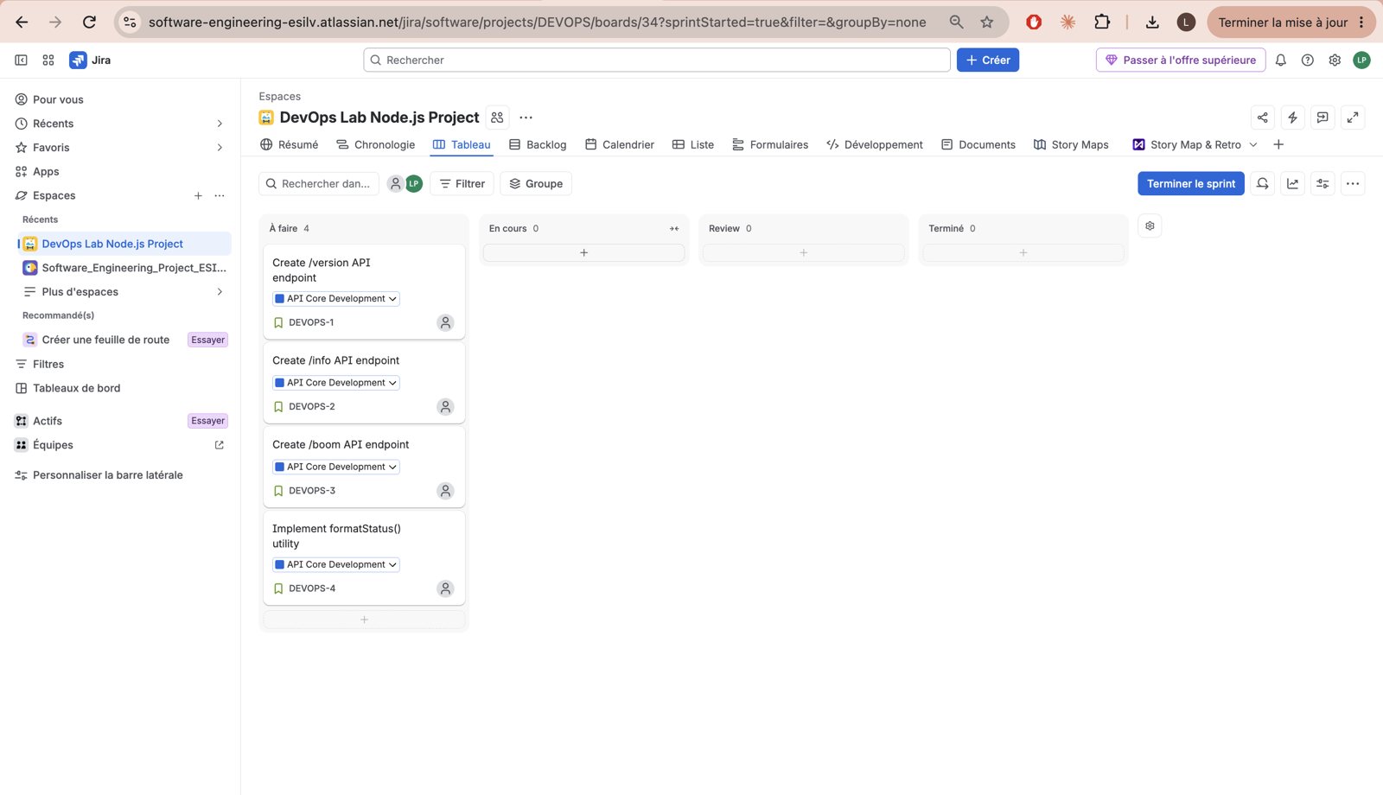
Figure 6 – Board at the start of the sprint: four stories in "To do", each tagged with its epic.

3. Step 2 – Code: branch, commit, pull request, merge
I cloned the team repository (Thanh-Poth/Software_Engineering_Lab_4), where I was added as a collaborator, and worked on a dedicated branch named after my ticket: feature/DEVOPS-2-info-endpoint. Branch, commit and pull request all carry the ticket key, which is what lets Jira show them in the ticket's Development panel.
Item | Value
Ticket | DEVOPS-2 – Create /info API endpoint
File changed | src/routes/auto/info.route.js
Commit message | feat(DEVOPS-2): return explicit fields and rounded uptime in /info
Pull request | #4, titled DEVOPS-2 | Implement /info endpoint, review requested from and approved by a teammate (FFW-gus)
Commit on main | 71184ff
The endpoint already existed in a basic form. I changed the route so that it builds its response explicitly from the two helpers in src/utils/appInfo.js and rounds the uptime to two decimals:
router.get('/info', (_req, res) => {
const { name, version } = getPackageInfo()
const { node, uptime } = getRuntimeInfo()
res.status(200).json({ name, version, node, uptime: Number(uptime.toFixed(2)) })
})
The diff is small (+3 −2) on purpose: the lab asks for the change to stay in the designated file, so I did not touch the helpers or the existing tests.
After the reviewer approved the pull request and CI was green, I moved DEVOPS-2 to Done. The Development panel of the ticket then showed the branch, the commit, the pull request and the build.
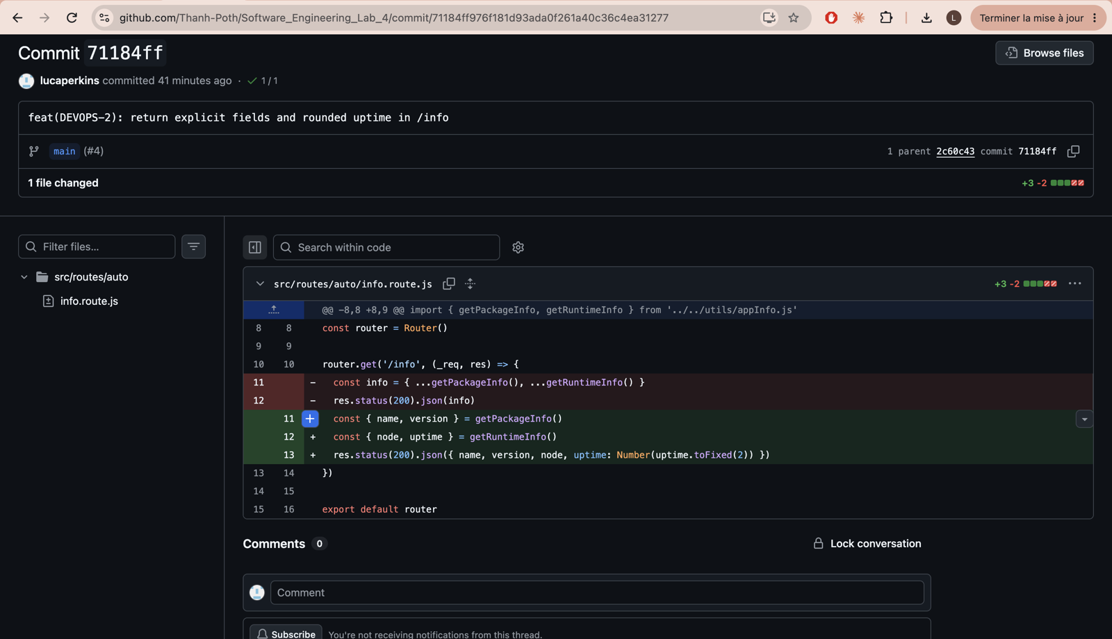
Figure 7 – Commit 71184ff: one file changed (+3 −2). The two old lines are replaced by explicit destructuring and a rounded uptime.
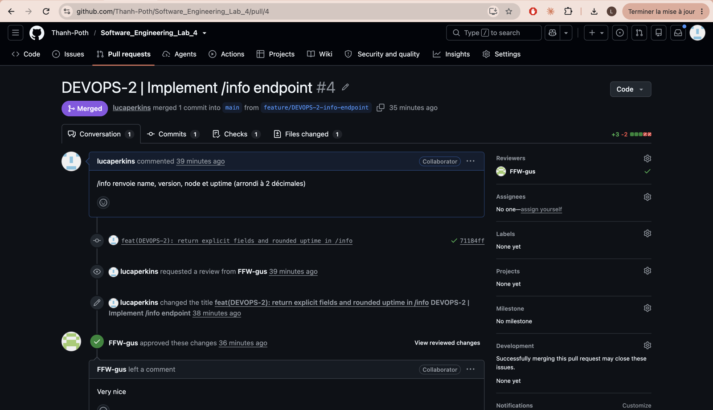
Figure 8 – Pull request #4 DEVOPS-2 | Implement /info endpoint: review requested from a teammate (FFW-gus), approved, then merged into main.
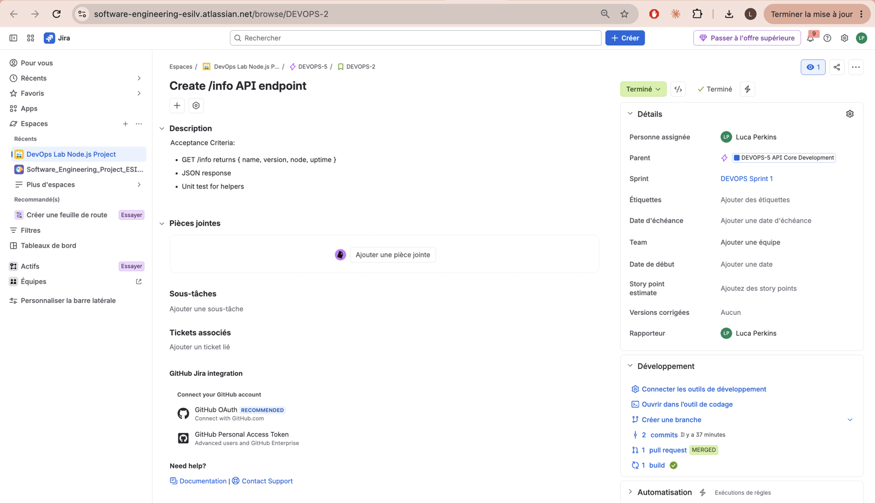
Figure 9 – DEVOPS-2 in Jira: status Done, parent epic DEVOPS-5, and in the Development panel 2 commits, 1 merged pull request and 1 successful build.

4. Step 3 – Build: continuous integration with GitHub Actions
Continuous integration (CI) means that every push and pull request is built and tested automatically on a clean machine, so a broken change is caught before it reaches main. The workflow lives in .github/workflows/ci.yml and runs one job, build-and-test, with these steps:
- Check out the code.
- Install Node.js 20 with the npm cache enabled.
- npm ci – clean install from package-lock.json.
- npm run lint – ESLint.
- npm test -- --coverage – Vitest with coverage thresholds.
- Upload the coverage folder as an artifact named coverage-report.
For the pipeline to work I prepared the repository files it depends on: a package-lock.json (required by npm ci), an .eslintrc.cjs for the lint step, a .gitignore, and an .npmrc containing legacy-peer-deps=true, which avoids an npm dependency-resolution crash.
The pipeline finished green on my branch (build #6) and again on main after the merge (build #9). Because the Jira GitHub integration is connected, the build result is also visible from the DEVOPS-2 ticket.
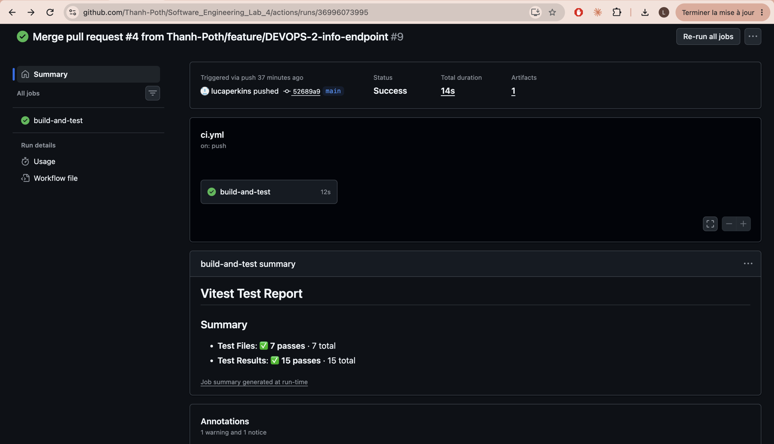
Figure 10 – GitHub Actions run #9, triggered by the merge into main: job build-and-test succeeded in 14 s, with the Vitest report (7 test files and 15 tests passing) and 1 artifact.
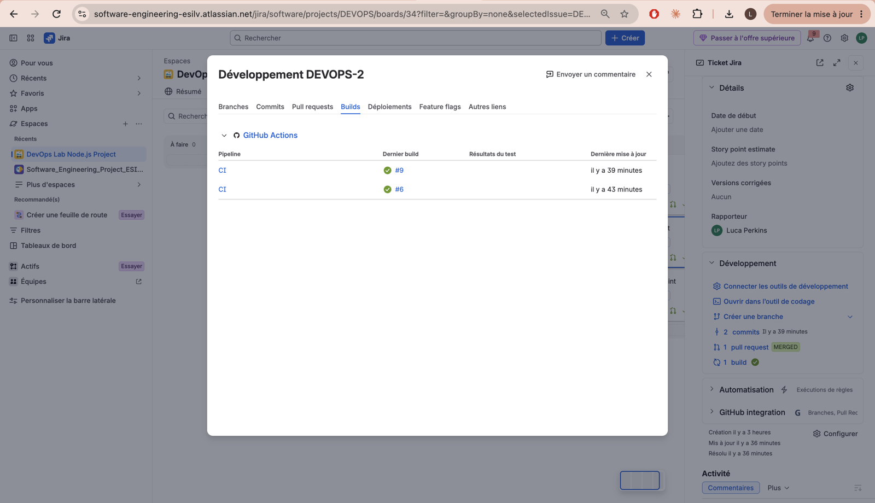
Figure 11 – The same builds appear in Jira under DEVOPS-2 (Development, Builds tab): CI #6 on the branch and CI #9 on main, both green.

5. Step 4 – Test and coverage
The suite passes: 7 test files and 15 tests, run with Vitest and Supertest. Two test files cover my endpoint: test/info.test.js calls GET /info and checks the types of name, version, node and uptime, and test/unit/appInfo.test.js tests the two helpers.
The coverage report is produced by CI and downloaded from the coverage-report artifact (open index.html). The thresholds enforced in vitest.config.js are 80% for lines, functions and statements, and 70% for branches.
Metric | Result | Threshold
Statements | 92.3% (48/52) | 80%
Branches | 72.22% (13/18) | 70%
Functions | 81.81% (9/11) | 80%
Lines | 93.33% (42/45) | 80%
src/routes/auto and src/utils, where my change lives, are both at 100%. The weakest file is src/index.js (0%), which only starts the server and is not imported by the tests.
On the merged main branch I also checked the three endpoints by hand:
$ curl localhost:3000/version
{"version":"1.0.0"}
$ curl localhost:3000/info
{"name":"devops-lab-student-project","version":"1.0.0","node":"v24.21.0","uptime":61.83}
$ curl localhost:3000/boom
{"error":true,"message":"Boom!"}
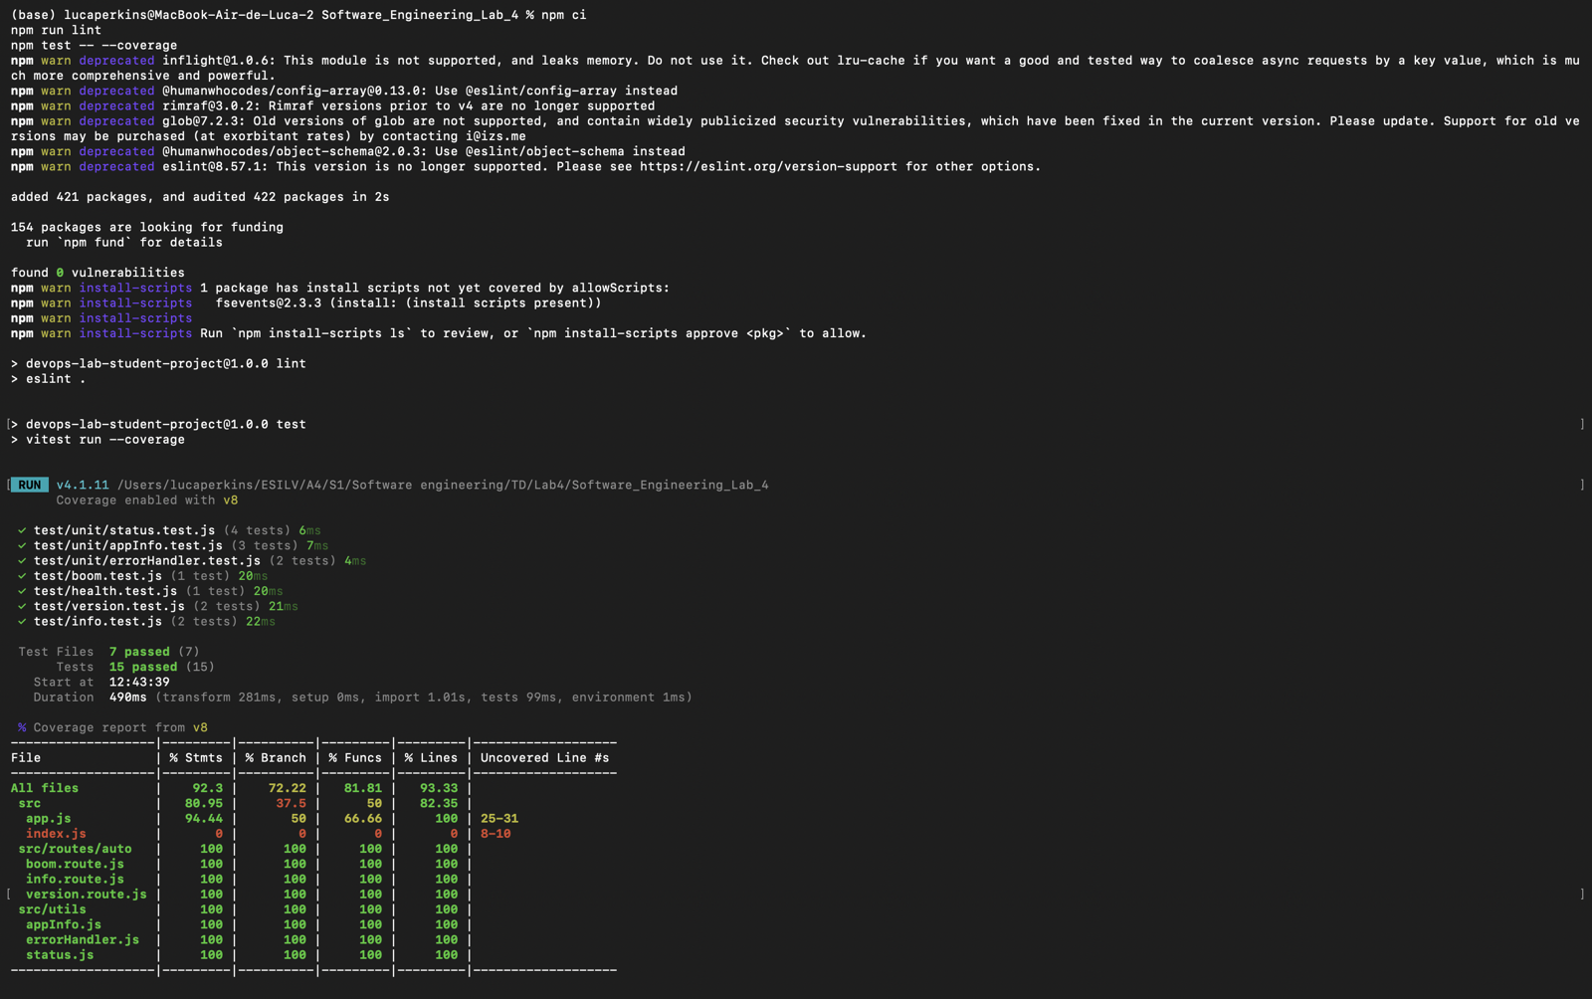
Figure 12 – Local run of npm ci, npm run lint and npm test -- --coverage: 7 test files and 15 tests passed, with the coverage table.
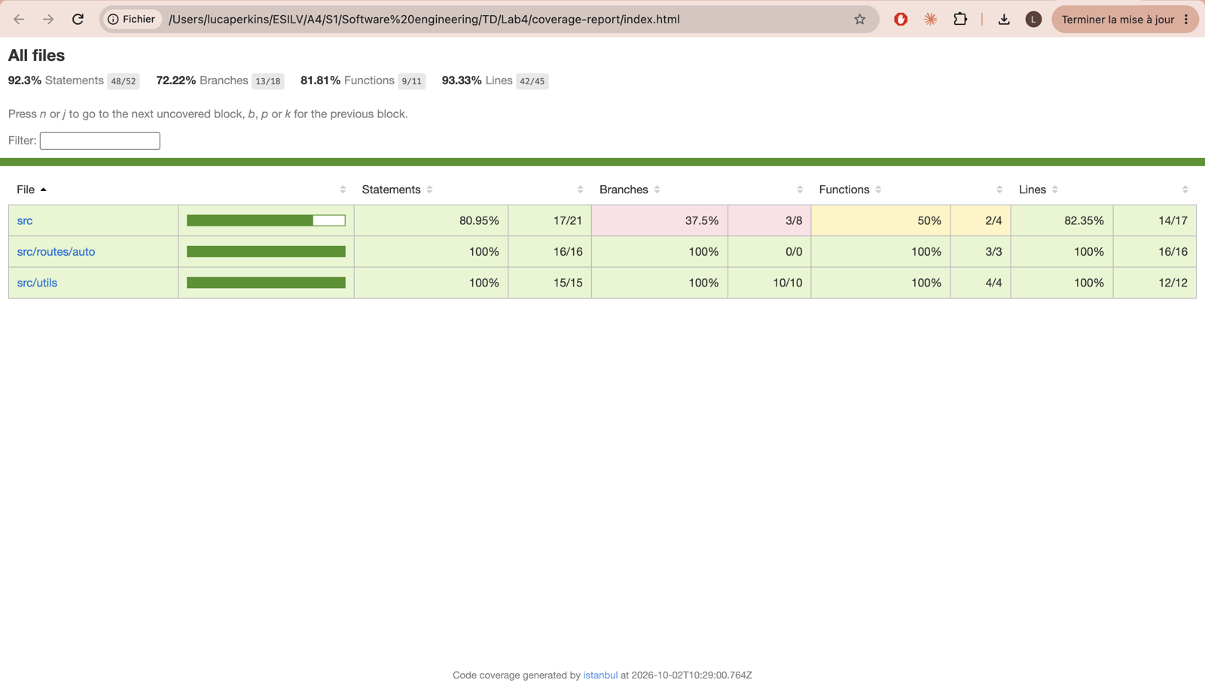
Figure 13 – The HTML coverage report (coverage-report/index.html): 92.3% statements, 72.22% branches, 81.81% functions, 93.33% lines.
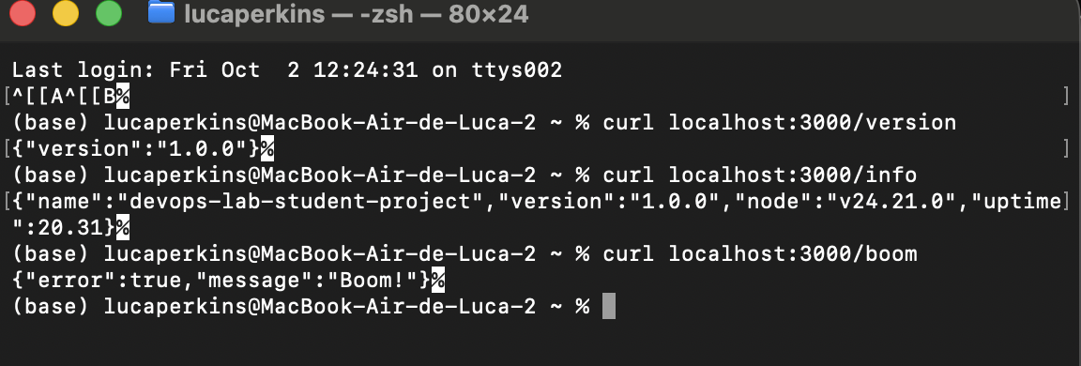
Figure 14 – Manual check of the three endpoints on the merged code.

6. Issues encountered and how I solved them
Problem | Cause | Solution
Epic type missing from the backlog quick-create menu | The inline menu only offers Bug and Task | Created the epic from the top "Create" button with Type = Epic
npm: command not found | Node.js was not installed on my machine | Installed Node.js LTS; npm ci then worked
CI would fail on npm ci | No package-lock.json in the repository | Generated and committed the lockfile
npm install crashed (Cannot read properties of null (reading 'edgesOut')) | npm 10 dependency-resolution bug with peer dependencies | Added .npmrc with legacy-peer-deps=true, then checked npm ci, lint and tests locally
Push refused when touching .github/workflows | The OAuth login lacked the workflow scope | Created a classic personal access token with repo and workflow scopes (kept private, never shared)
Push rejected, main had diverged | A teammate had uploaded files on GitHub in the meantime | git pull --rebase origin main, which applied cleanly
Route files showed 0% coverage | app.js loaded routes with require() | Fixed by a teammate in PR #1 (DEVOPS-5 fix); coverage thresholds were added at the same time

7. Conclusion and lessons learned
DEVOPS-2 went through the full loop: planned in Jira, coded on a feature branch, reviewed in pull request #4, built and tested by GitHub Actions, and merged into main with a green pipeline. The ticket is Done and links back to its branch, commit, pull request and build.
What I take from the lab:
- Traceability: putting DEVOPS-2 in the branch, commit and PR title connects code and planning without any manual work.
- CI as a safety net: the pipeline caught real setup problems (missing lockfile, lint configuration, coverage thresholds) before they reached main.
- Small, reviewed changes: a 5-line diff in one designated file was easy for a teammate to review and approve.
- Coverage is a signal, not a goal: 92% overall, yet my rounding logic has no dedicated test. A test for the exact keys and the two-decimal uptime would be a worthwhile follow-up.
Still open at team level: DEVOPS-4 is in progress, and the sprint DEVOPS Sprint 1 has not been closed in Jira yet.

